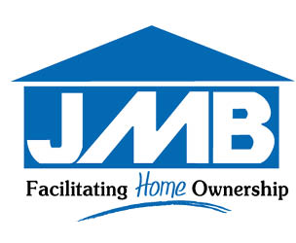

**VISITORS**

Resulting from the COVID-19 pandemic, we ask that you kindly comply with the following measures while visiting the Jamaica Mortgage Bank:

 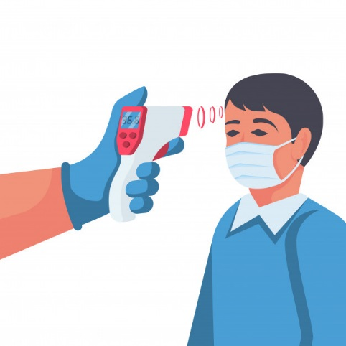 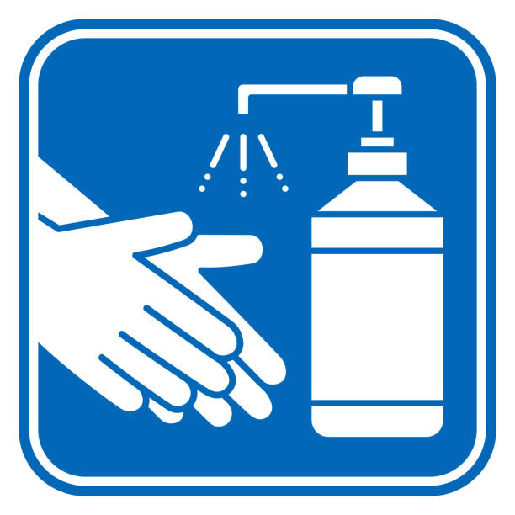

**WEAR A MASK**

**SANITIZE YOUR HANDS**

**GET YOUR TEMPERATURE CHECKED**